EDX3600H
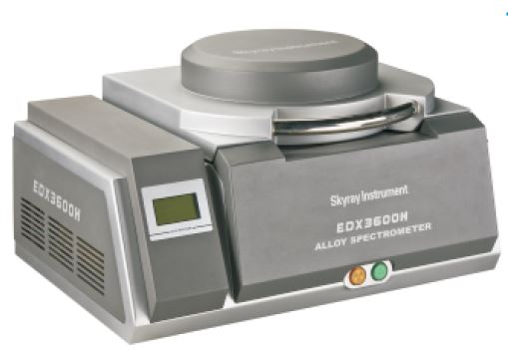

Product description, Technical parameters and configuration

Instrument introduction
The halogen –free plan with the new round environmental protection tide is the afforested policy which is greatly promoted by International Green and Peaceful Organization and supported by numerous international environmental protection organizations and international large-scale companies. The European Union 2002/95/EC Instruction, “Montreal Protocol”, “the Stockholm Treaty” and the board material laws and regulations of National Electrician Committee (IEC) have restricted on the halogen material. And, IEC 61249-2-21 in IEC laws and regulations stipulates that the maximum limit of chlorine, bromine and the overall halogen is: bromine and chlorine is less than 900ppm respectively; (bromine + chlorine) is less than 1500ppm.
Jiangsu Skyray Instrument Inc. specializes in high-performance X-ray Fluorescence Spectrometers in the world. EDX3600H, desktop, Non-halogen analysis spectrometer, introduced in 2009, is of high performance and high-technology halogen testing instrument. The technology, adopting the worldwide leading non-halogen analysis technology, equipped with the best intelligent vacuum system for non-halogen testing and using low energy X-ray to excite light element, thus solve testing problem of chlorine and bromine. The instrument can detect any products containing hazardous substance halogen. In addition, it can be used in all element and RoHS analysis. The instrument is of multi-functional and can meet the international newest standard.
Performance characteristics
Made in USA, halogen testing, X-ray tube of high efficient; the specification reaches the international advanced level.
Special accessories are developed for testing halogen element (especially chlorine element)
S100 detector, excellent energy linearity, energy resolution and energy spectrum characteristics. Higher peak-to-background ratio.
Skyray instrument patent product- Signal-Noise-Enhancer (SNE) improves the signal processing ability up to 25 times.
Low energy X-rays are used, delivering good results when exciting light elements such as CI, Br.
Intelligent pumping vacuum system; shield air influence and enlarge testing scope.
Auto spectrum stabilizer ensures the instrument working.
High SNR electronic circuit unit
Auto collimator and filter switch, exempt from trouble by manual.
Spectrum unfolding technology decomposes the spectrum peak; ensuring CI, Br and other light elements testing have the equal analysis accuracy.
Multiple linear regression, reducing the inter elemental absorption and enhancement effect
In-built CCD with high resolution
LCD makes the important parameter (tube voltage, tube current, vacuum) of the instrument obvious.

Technical specifications
Measurable elements: Na to U.
Element contents: 1ppm—99.99%
Ability of simultaneous analysis: Simultaneously analysis of 24 elements.
Plating thickness: up to 0.005um each layer; it is able to analyze plating with more than 3 layers.
Analysis accuracy: 0.05%
Measurement time: 60s-200s
Energy resolution: （150±5）eV
Tube voltage: 5KV-50KV
Tube current: 50uA-1000uA
Forms of samples: powder, solid and liquid

Standard configurations
Halogen testing, X-ray tube of high efficiency.
S100 detector
Signal-Noise-Enhancer SNE
Special accessories for halogen testing
Light path enhancement system
High SNR electronic circuit unit
In-built high resolution CCD
Automatic collimator and filter switch
Auto spectrum stabilizer
Triple safety protection model
Independent matrix effect correction model
Multi-variable non-linear regression procedure
Overall steel support structure
90mm*70mm LCD

Application fields
Non-halogen testing All element analysis RoHS testing Plating thickness

